Q) Enhance the Guesser Game Project which you have learnt in live class. Add the

maximum feature you could add to it.

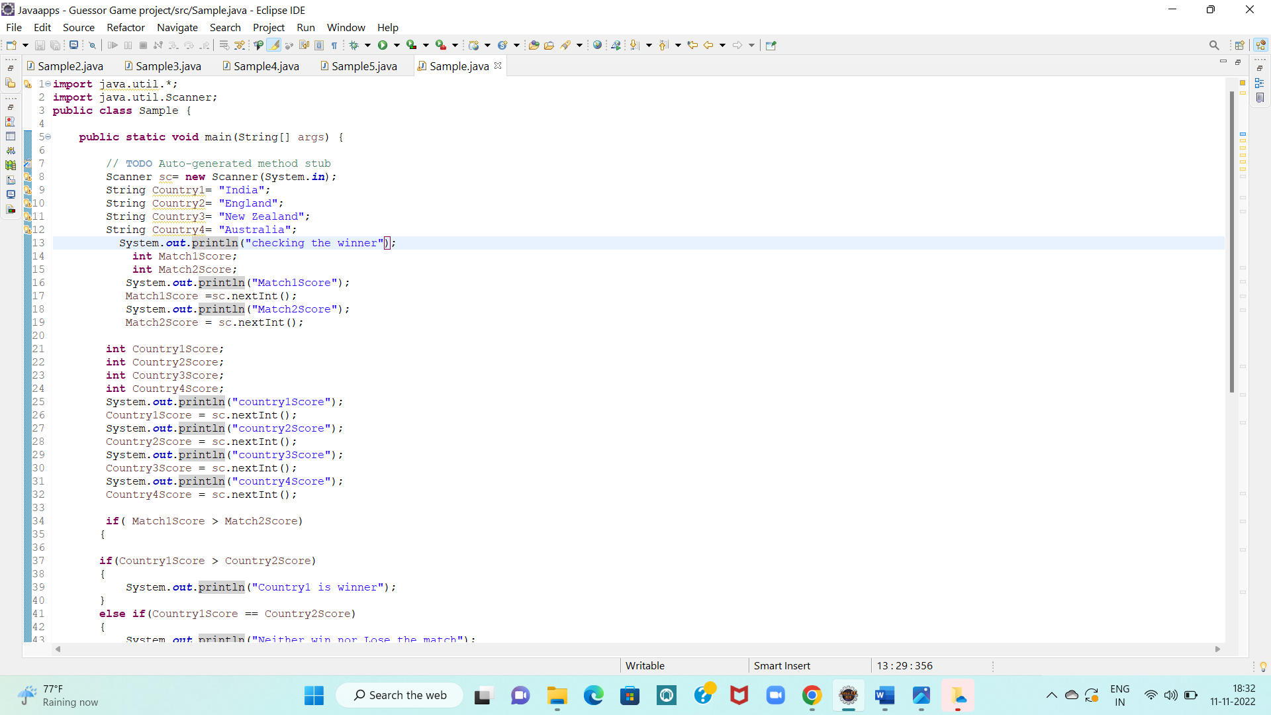

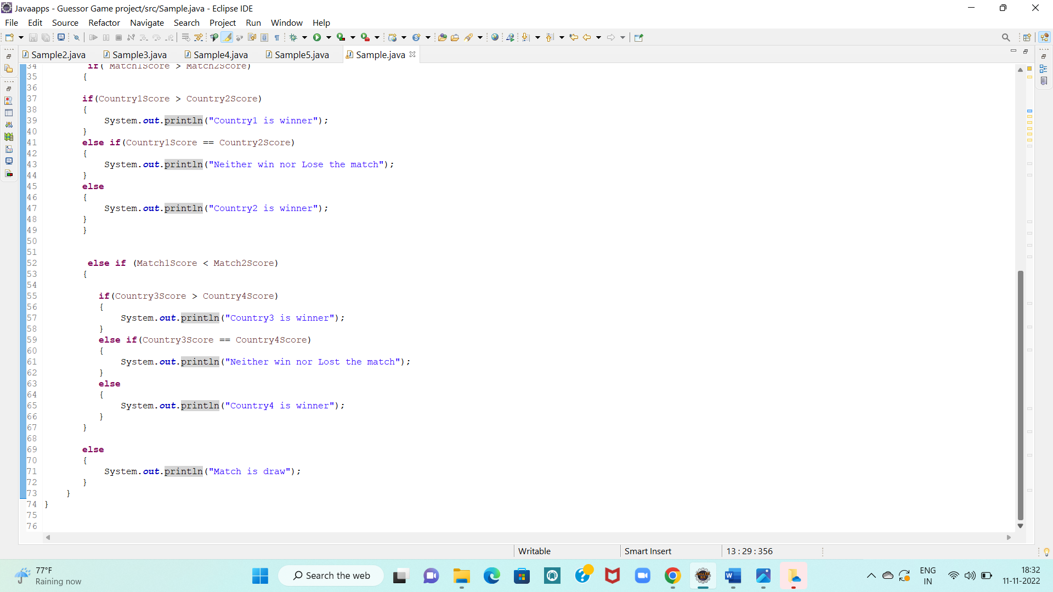

OUTPUT:

